10:10 PM

Task: Hosting 3 Web Templates on Same IP on Ec2 Instance

Step 1: Launching Ec2 Instance With Ubuntu AMI

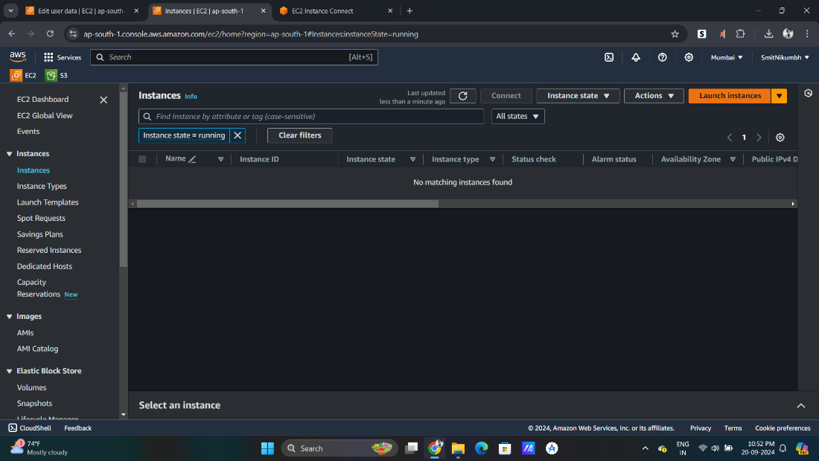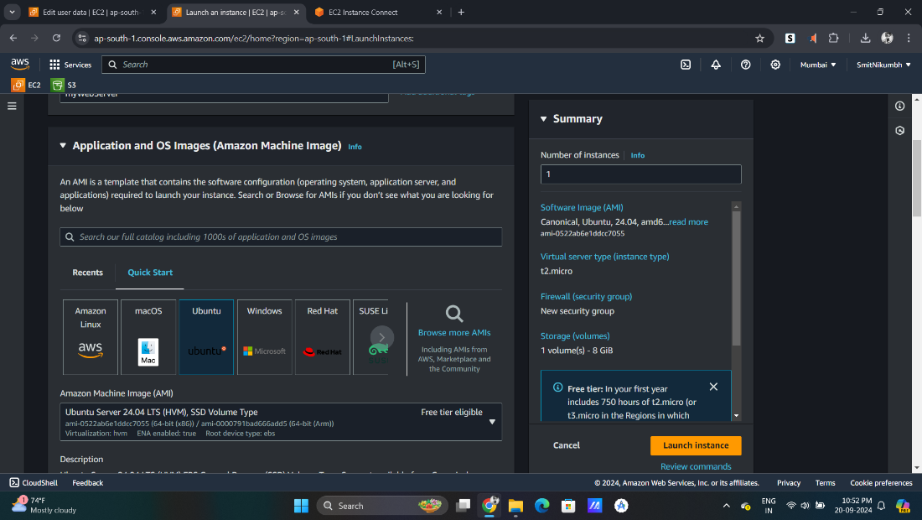

Step2: Creating Key Pair and Security Group For SSH Connect

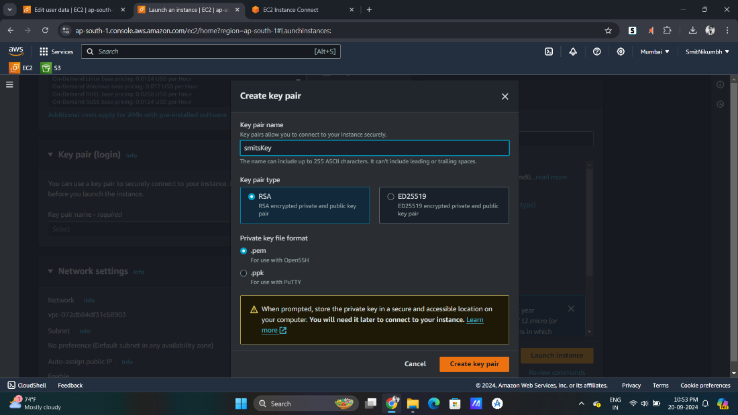

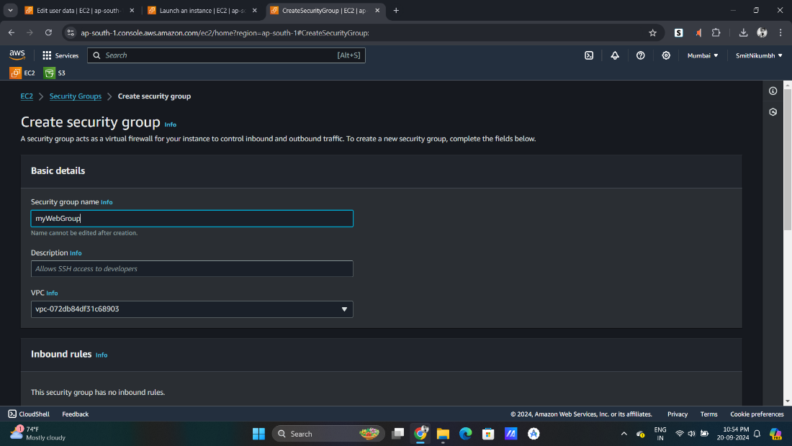

Step3: In inbound Rules allow SSH and HTTP from anywhere

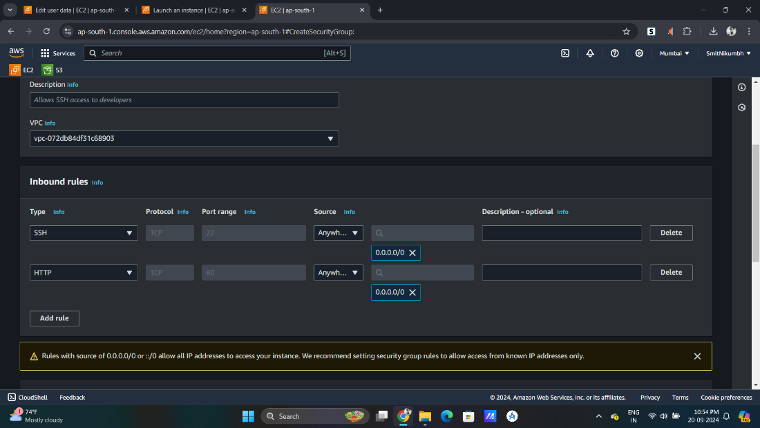

Step4: Keeping Default all setting Launch the Instance :)

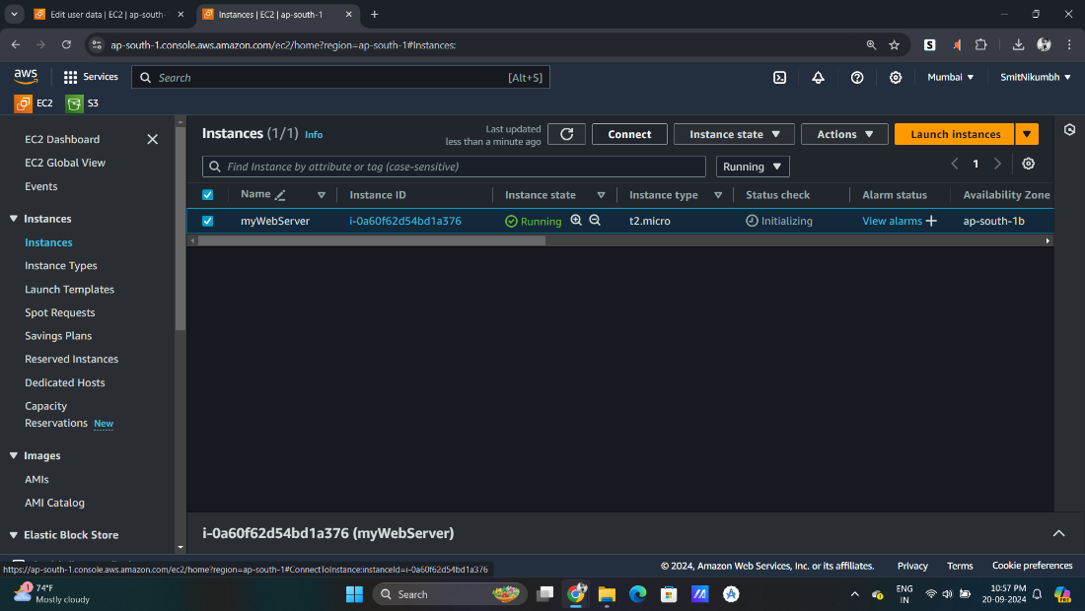

Step5: Click On Connect and Select SSH Client and Copy ssh client address

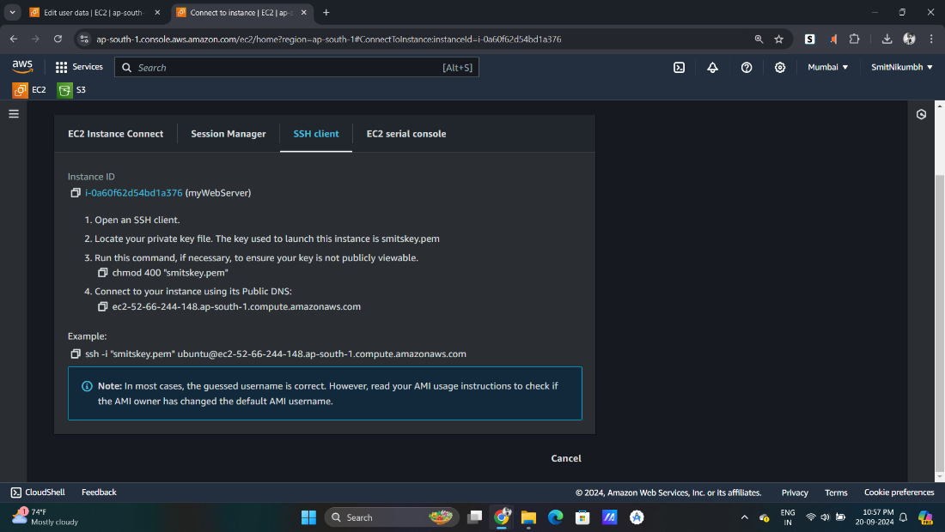

Step6: Open your command Prompt and goto the location where your key is downloaded

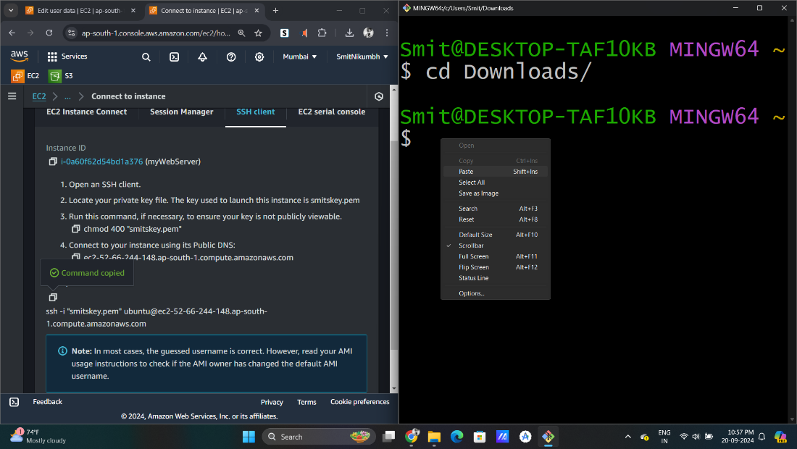

Step 7: Paste the copied command in cmd

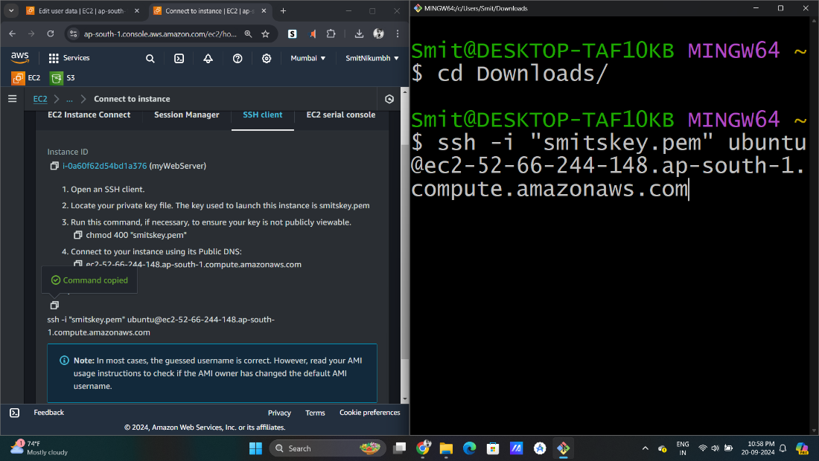

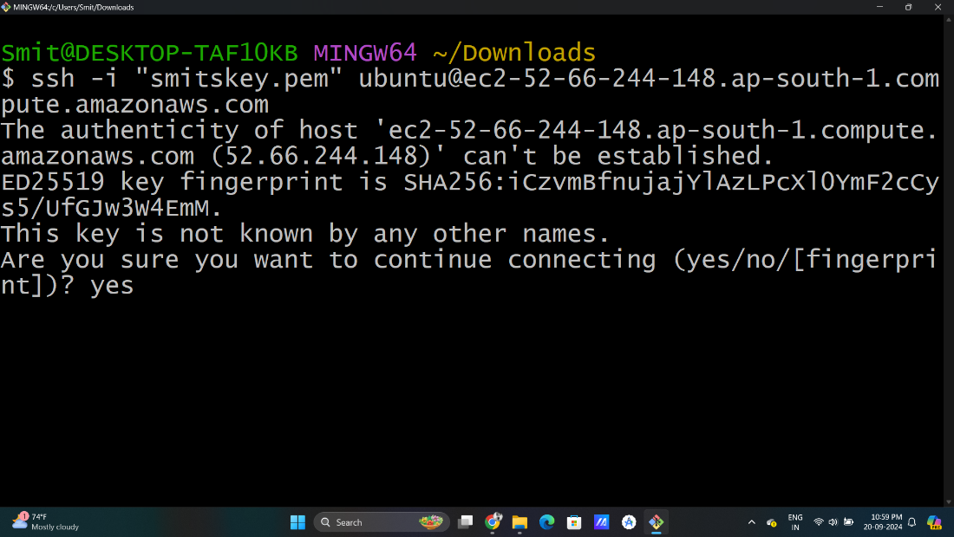

Step8: Now we are successfully connected to Our EC2 Instance

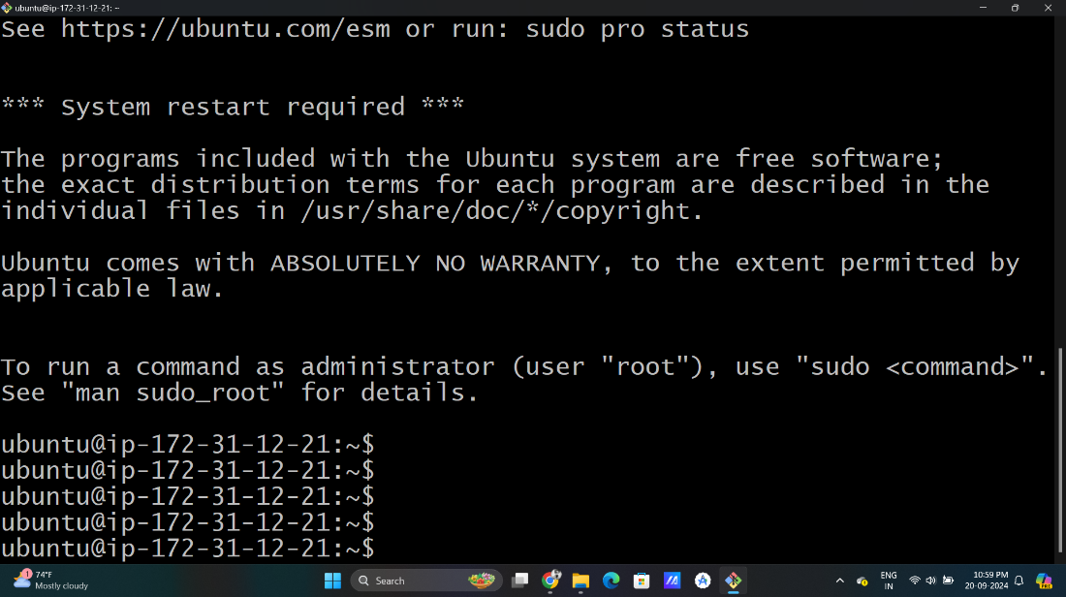

Step9: Now Updating Our Machine and Installing Apache Server and Unzip with following Commands

* sudo apt update
* sudo apt upgrade -y
* sudo apt install apache2
* sudo apt install wget unzip -y

Step10: After running commands check the status of apache Server.

Its Active :)

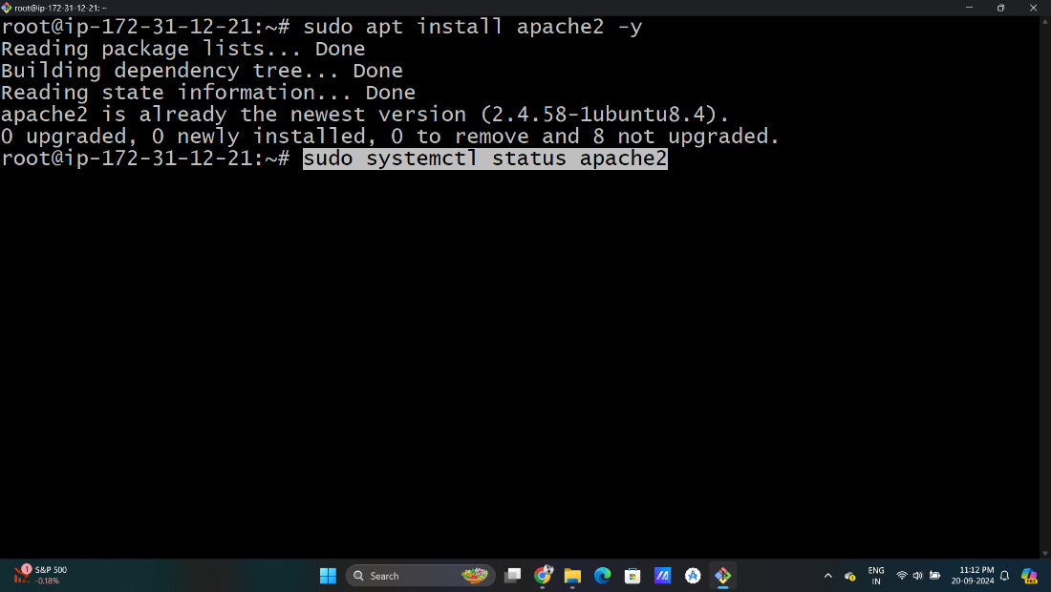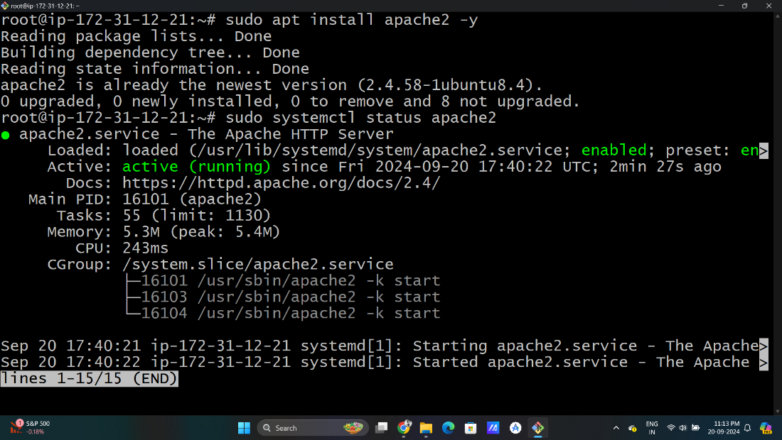

Step11: Now going to Apache server File Location and we will get default index.html

* cd /var/www/html
* ls

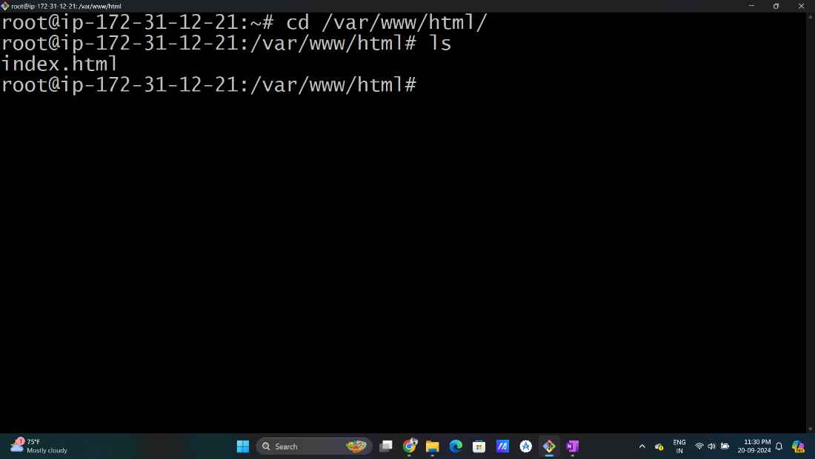

Step12: Making 3 Folders for our Website Templates and removing default index.html

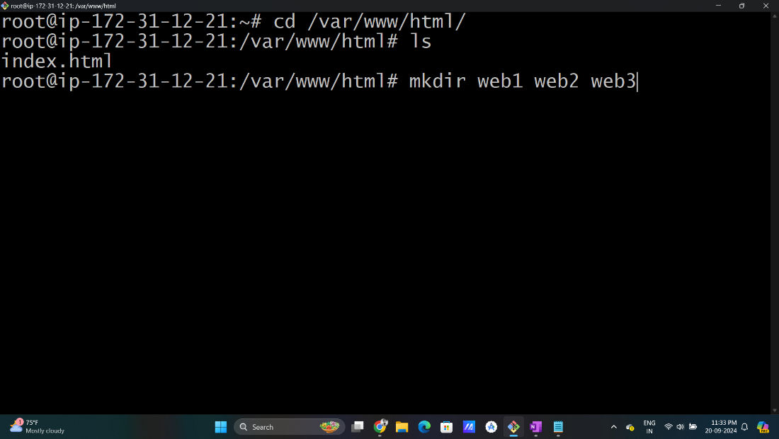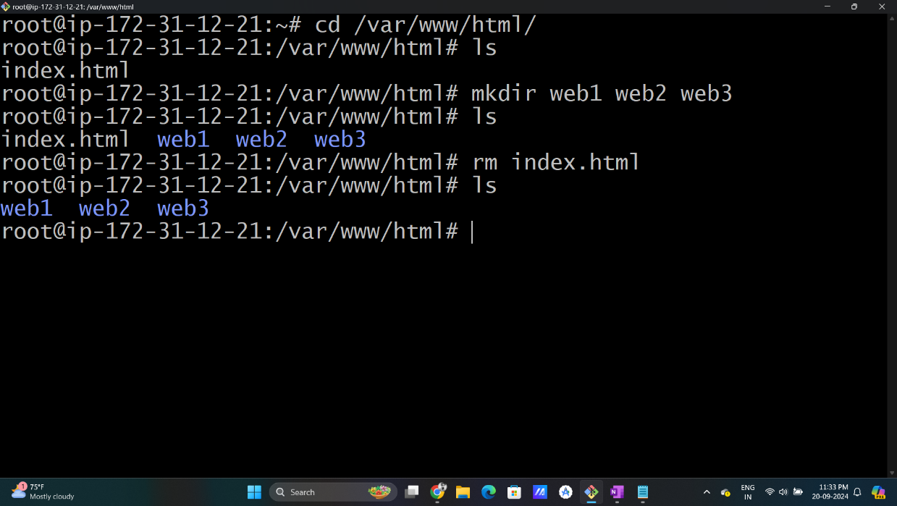

Step13: Now we can get our own web templates from any opensource sites in our case we will be using tooPlate.

We Will Install and unzip templates using below commands in our Ubuntu from Tooplate

*Run all the below Commands One By One

//getting first template and unzip and pasting it in our web1 folder

wget <https://www.tooplate.com/zip-templates/2135_mini_finance.zip>

unzip 2135_mini_finance.zip

sudo cp -r 2135_mini_finance/* /var/www/html/web1

//getting second template and unzip and pasting it in our web2 folder

wget <https://www.tooplate.com/zip-templates/2128_tween_agency.zip>

unzip 2128_tween_agency.zip

sudo cp -r 2128_tween_agency/* /var/www/html/web2

//getting third template and unzip and pasting it in our web3 folder

wget <https://www.tooplate.com/zip-templates/2136_kool_form_pack.zip>

unzip 2136_kool_form_pack.zip

sudo cp -r 2135_mini_finance/* /var/www/html/web3

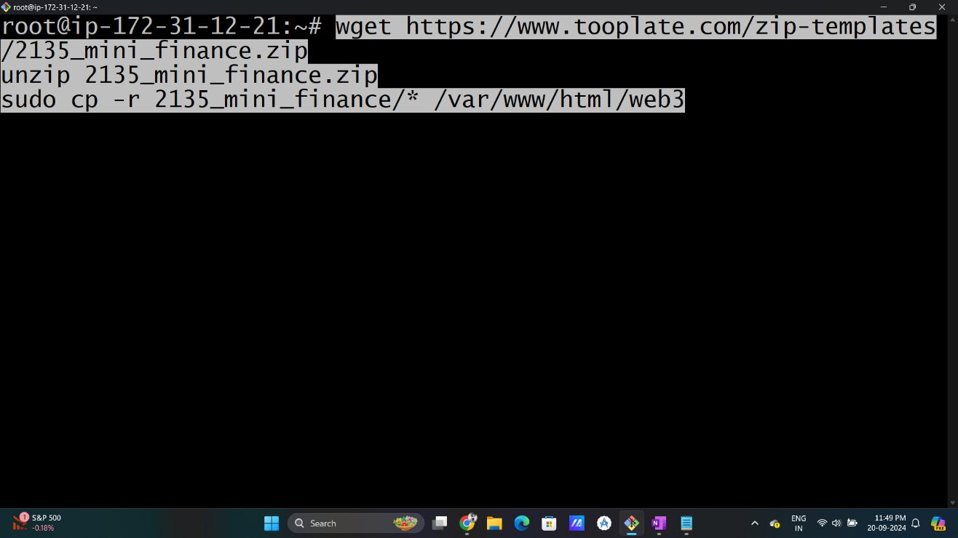

Step14: Now We are done.. Go to your instace and open public IP. [Remove 'S' from Https] it should be only http.

Now you can view all 3 Web-Pages using single IP using sub-domain /web1 , /web2, /web3

